**Research Project**

**On**

**“The Economic Decision-Making of University Students:**

**A Study on Financial Literacy and Spending Behavior”**

**Course Name:**

**Computer Fundamentals & Office Applications**



**Submitted To:**

**Dr. Tania Islam**

Assistant Professor,

Department of CSE

University of Barishal

**Submitted By:**

**Md. Sakib Mahmud**

Roll: 20 ECO 047, Reg: 311-047-20

3rd Year 1st Semester

Department of Economics

University of Barishal.

**1.Introduction**

Economic decision-making is the process of choosing how to allocate scarce resources. It is a complex process that is influenced by a variety of factors, including personal preferences, financial knowledge, and social norms. University students are a particularly important group to study economic decision-making, as they are making many important financial decisions for the first time, such as choosing a major, taking out loans, and managing their budget.

Financial literacy is the ability to understand and use financial information to make informed financial decisions. It is an important skill for everyone, but it is especially important for university students, who are often faced with complex financial choices.

Spending behavior is the way that people allocate their money. It is influenced by a variety of factors, including income, financial knowledge, and social norms. University students often have limited incomes, so it is important for them to be able to manage their money wisely.

This research aims to understand the economic decision-making of university students, particularly in relation to their financial literacy and spending behavior. Key objectives include:

* Assessing the level of financial literacy among university students.
* Analyzing the factors influencing their spending behavior.
* Investigating the relationship between financial literacy and spending behavior.
* Identifying potential areas for improving financial education programs for university students.

**2. Literature Review**

**2.1 Financial Literacy**

Financial literacy encompasses a range of skills and knowledge required to make informed financial decisions. It includes understanding topics such as budgeting, saving, investing, debt management, and financial planning. Previous studies have shown that a higher level of financial literacy is associated with better financial decision-making and outcomes (Lusardi & Mitchell, 2011).

**2.2 University Students and Financial Literacy**

University students, despite being well-educated in various fields, often exhibit low levels of financial literacy. This could be due to a lack of formal financial education in the curriculum or a lack of experience in managing personal finances independently. Research has shown that students with higher financial literacy are better equipped to handle financial challenges during their university years (Robb & Woodyard, 2011).

**2.3 Spending Behavior**

Spending behavior refers to how individuals allocate their financial resources to different categories such as education, housing, food, entertainment, and savings. University students often face unique spending challenges, including tuition fees, textbooks, and living expenses. Their spending habits during this period can have long-term financial consequences.

**2.4 Financial Literacy and Spending Behavior of University Students**

Previous studies have suggested that university students often face unique financial challenges, including managing student loans and credit card debt. These challenges can impact their financial literacy and spending behavior. However, the relationship between financial literacy and spending behavior among university students remains underexplored.

**3.** **Methodology:**

**3.1 Data Collection:**

Data for this study were collected from a sample of 100 university students aged between 18 and 24 years. Participants were selected from various academic disciplines to ensure diversity. A structured questionnaire was administered to collect information on financial literacy and spending behavior.

**3.2 Variables**

* **Financial Literacy:** Measured using a composite score based on respondents' knowledge of financial concepts, including budgeting, saving, investing, and debt management.
* **Spending Behavior:** Assessed by examining respondents' spending patterns, including discretionary and non-discretionary expenses.
* **Income Sources:** Identified the primary sources of income for university students.

**3.3 Data Analysis**

Descriptive statistics were used to summarize the characteristics of the sample. Regression analysis was employed to explore the relationship between financial literacy and spending behavior while controlling for demographic variables.

The research on the relationship between financial literacy and spending behavior is still in its early stages, but the findings suggest that financial literacy can play an important role in helping students make sound economic decisions.

**4.** **Findings**

The finding section presents the findings of the study. It includes data on participants' demographic characteristics, financial literacy scores, and spending behavior. The section also explores the relationship between financial literacy and spending habits.

**4.1 Financial Literacy**

Our analysis revealed that a significant proportion of university students lacked basic financial knowledge.

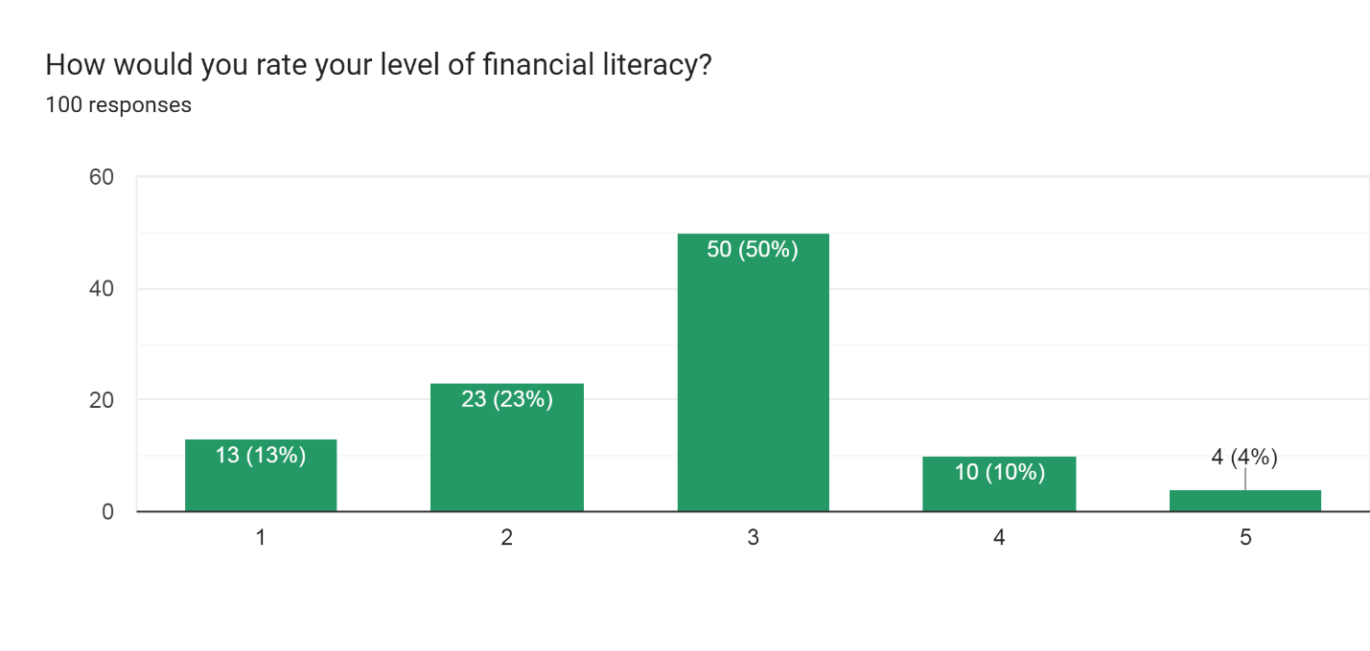

**Figure:** Rating level of financial literacy

The bar chart shows that most people have an average level of financial literacy, but there is a significant minority of people with a high or very high level of financial literacy, as well as a small minority of people with a very low level of financial literacy. In short, the bar chart shows that most people have an average level of financial literacy, but there is still a need to improve financial literacy among the population.

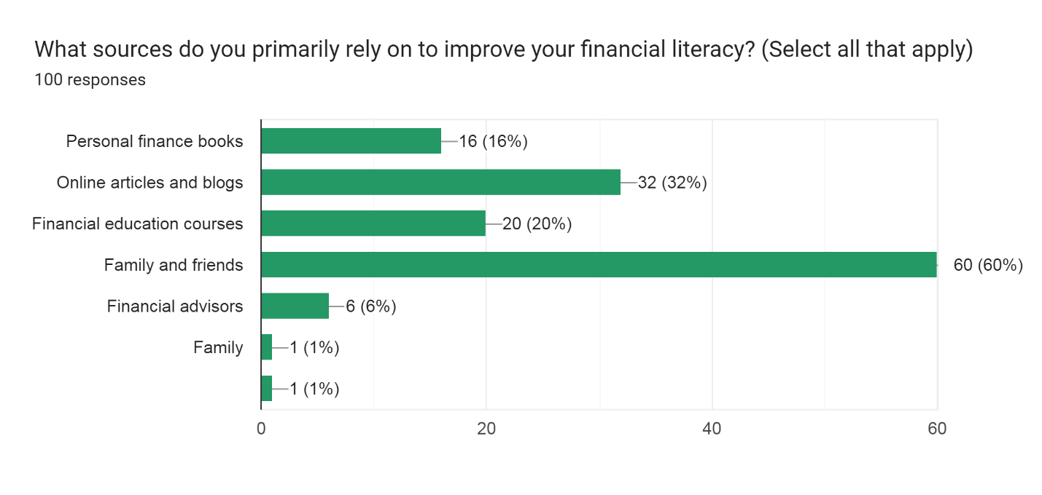**Figure:** Primarily rely on to improve your financial literacy

The bar chart shows the percentage of people who rely on different sources to improve their financial literacy. The most popular source is personal finance books, with 60% of people using them. This is followed by online articles and blogs (32%), financial education courses (20%), family and friends (60%), and financial advisors (6%).

It is interesting to note that the majority of people are relying on self-directed learning to improve their financial literacy. This is likely due to the fact that personal finance books and online articles and blogs are readily available and free to use. However, it is important to note that these sources may not always be accurate or reliable.

Financial education courses and financial advisors can be a valuable resource for people who are looking for more in-depth or personalized financial advice. However, these resources can be more expensive and time-consuming than self-directed learning.

Overall, the bar chart shows that there is a variety of resources available to help people improve their financial literacy. The best source for a particular person will depend on their individual needs and preferences.

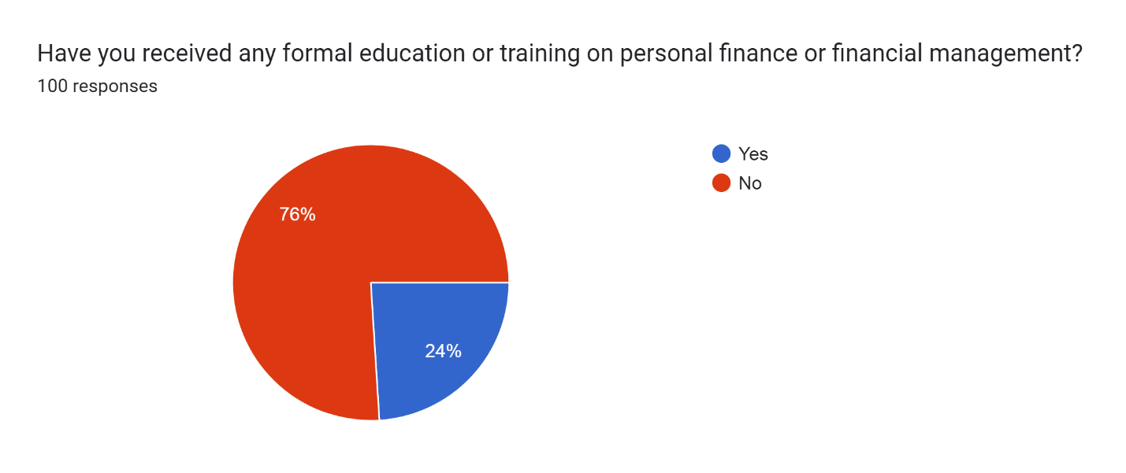

**Figure:** Receiving formal education or training on personal finance or financial management

The pie chart shows the percentage of people who have received formal education or training on personal finance or financial management. 76% of people have received formal education or training, while 24% have not.

This suggests that the majority of people recognize the importance of financial literacy and are taking steps to improve their knowledge and skills in this area. This is a positive trend, as financial literacy is essential for making sound financial decisions and achieving financial goals.

However, it is important to note that there is still a significant minority of people who have not received formal education or training on personal finance or financial management. This group may be more vulnerable to financial problems, such as debt and bankruptcy.

More needs to be done to ensure that everyone has access to financial education. This could include making financial education a mandatory part of the school curriculum, offering free or low-cost financial education courses, and providing financial education resources in libraries and community centers.

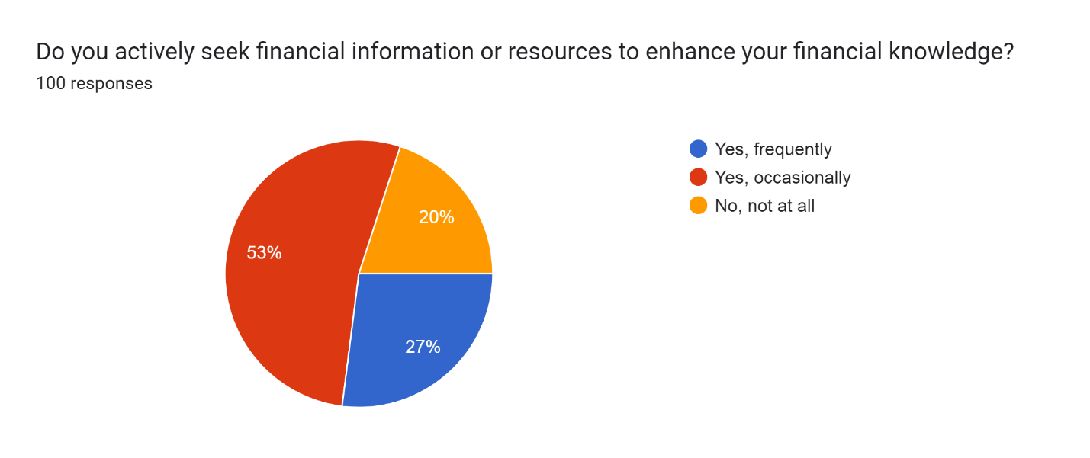

**Figure:** Actively seek financial information or resources to enhance your financial knowledge

The pie chart shows the percentage of people who are actively seeking financial information on websites. The pie chart is divided into three sections, each with a different color. The first section (53%) shows the percentage of people who are actively seeking financial information on websites frequently. The second section (27%) shows the percentage of people who are actively seeking financial information on websites occasionally. The third section (20%) shows the percentage of people who are not actively seeking financial information on websites.

This pie chart suggests that a majority of people are interested in learning more about their finances. This is a positive trend, as financial literacy is essential for making sound financial decisions and achieving financial goals. However, it is important to note that there is still a significant minority of people who are not actively seeking financial information on websites. This group may be more vulnerable to financial problems, such as debt and bankruptcy.

**4.2 Spending Behavior**

The spending behavior of university students was diverse, with differences in priorities and allocation of funds. Some students prioritized education-related expenses, while others allocated more resources to discretionary spending.

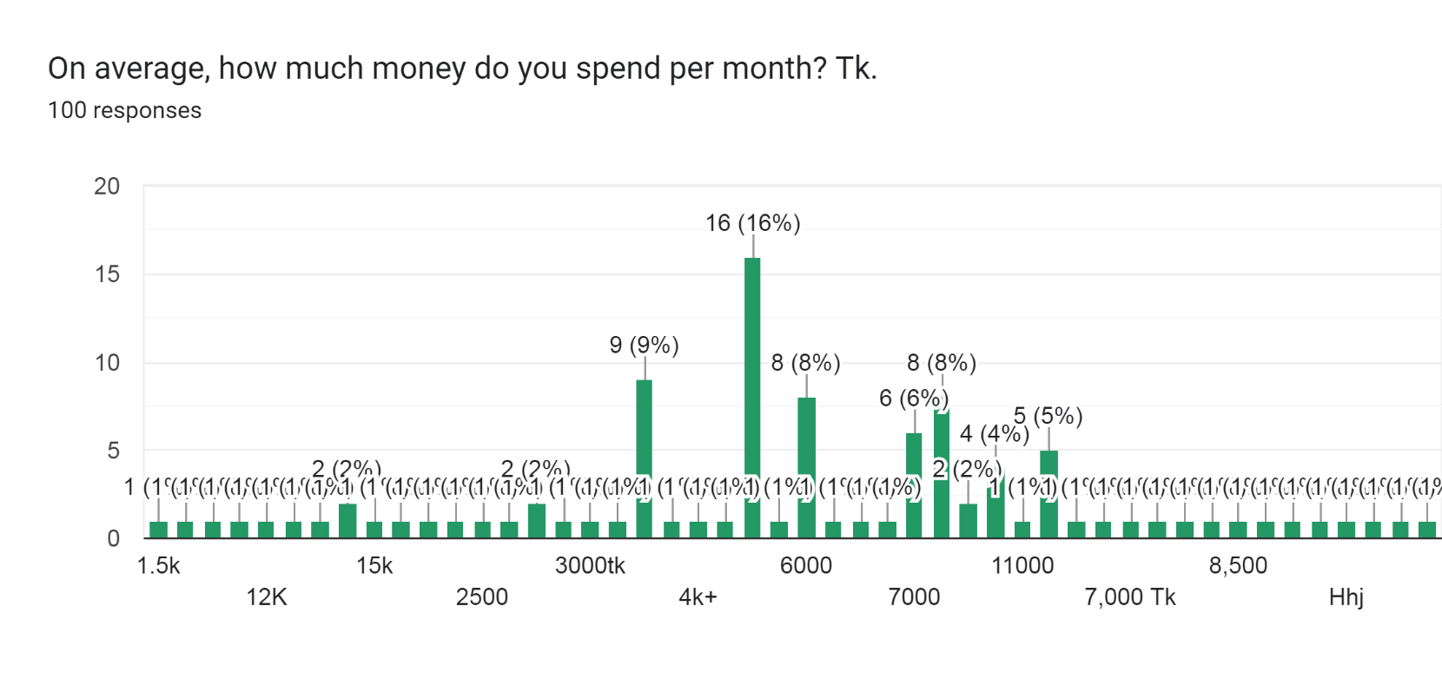

**Figure:** On average, spending per month (Tk.)

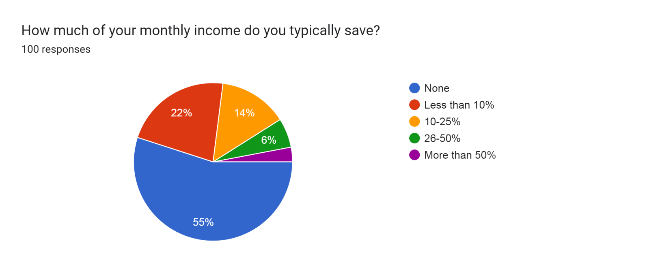The most common monthly expenditure is between Tk. 5,000 and Tk. 10,000, with 22% of respondents reporting spending in this range. The next most common range is Tk. 10,000 to Tk. 15,000, with 16% of respondents. Only 8% of respondents report spending less than Tk. 5,000 per month, while 8% report spending more than Tk. 15,000 per month.

**Figure:** Monthly income do you typically save

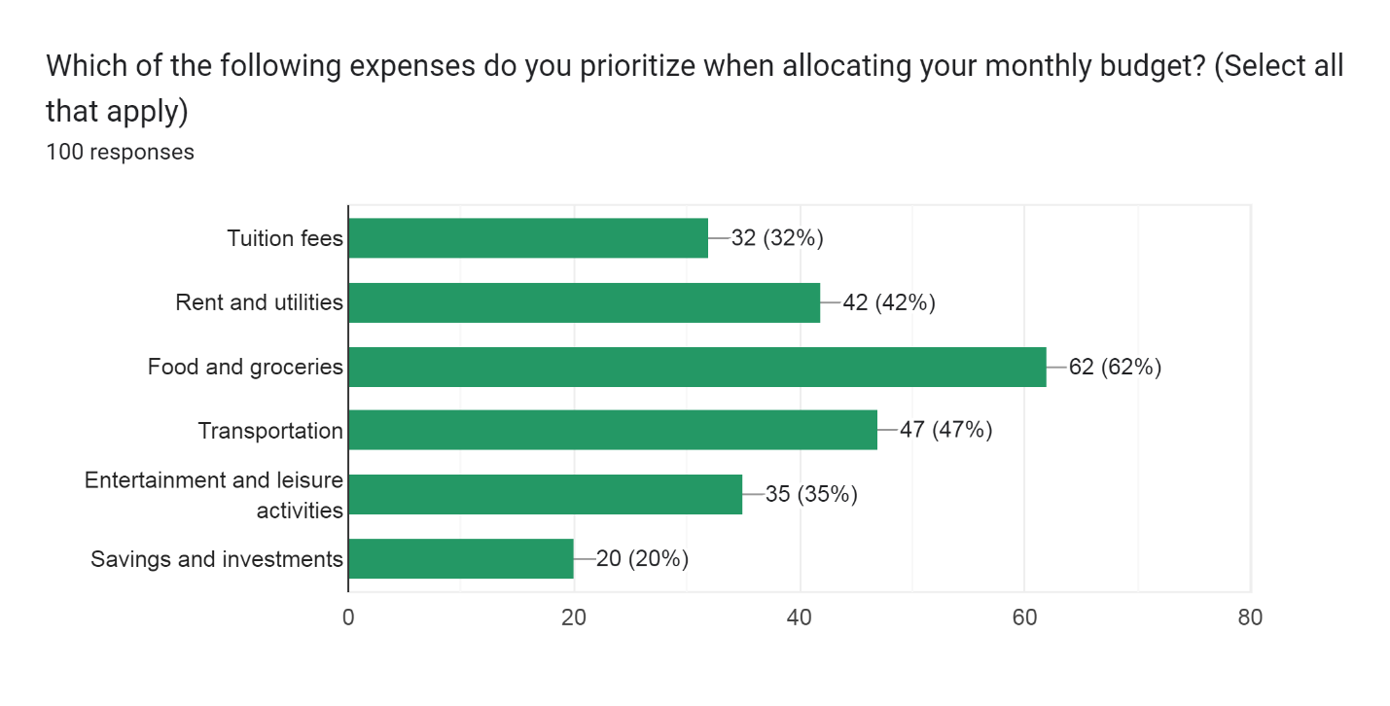The pie chart you sent shows the percentage of your monthly income that you typically save. The largest slice of the pie is "Less than 10%", which accounts for 55% of your income. This means that you are saving less than 10% of your income each month. The next largest slice of the pie is "None", which accounts for 22% of your income. This means that you are not saving any money at all each month. The remaining slices of the pie are "10-25%" (14%), "26-50%" (6%), and "More than 50%" (3%). This means that a small percentage of people are saving a significant amount of their income each month. Saving money can be difficult, but it is important to remember that every little bit counts. Even if you can only save a few dollars each month, it will add up over time.

**Figure:** Prioritize when allocating monthly budget

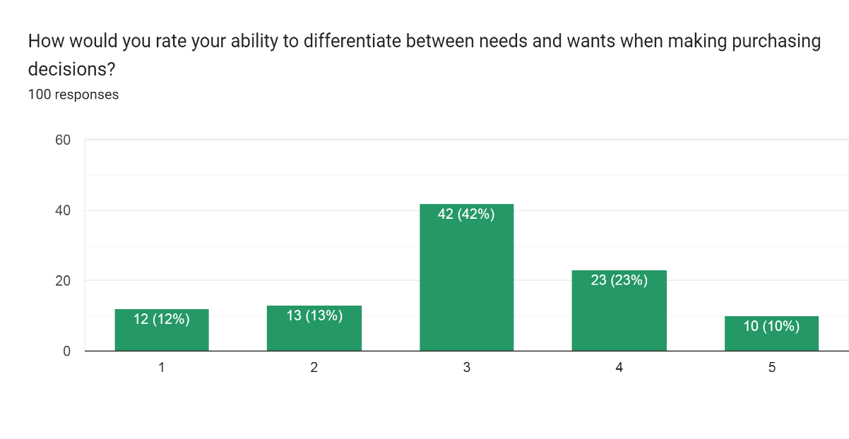The graph you sent shows the percentage of people who prioritize which of the following expenses when allocating their monthly budget. The survey asked 100 people to select all of the expenses that they prioritize. The most prioritized expense is food and groceries, with 62% of people selecting it. This is likely because food is a basic necessity that everyone needs to survive. The next most prioritized expense is rent and utilities, with 47% of people selecting it. This is also likely because rent and utilities are essential expenses that most people need to pay in order to have a place to live and basic necessities like electricity and water. Transportation is the third most prioritized expense, with 42% of people selecting it. This is likely because transportation is necessary for many people to get to work, school, and other essential activities. Tuition fees is the fourth most prioritized expense, with 32% of people selecting it. This is likely because education is important to many people and they want to invest in their children's future. Savings and investments is the fifth most prioritized expense, with 20% of people selecting it. This is a good sign because it shows that people are thinking about their long-term financial future. Entertainment and leisure activities is the least prioritized expense, with 35% of people selecting it. This is likely because people are more focused on essential expenses and saving money, especially during difficult economic times. Overall, the graph shows that people are prioritizing essential expenses such as food, rent, and transportation. However, a significant number of people are also prioritizing saving money for the future. This is a good sign because it shows that people are thinking about their long-term financial well-being.

The graph shows how people rate their ability to differentiate between needs and wants when making purchasing decisions. The data is based on a survey of 100 people. The most common response is "Good," with 42% of people rating their ability to differentiate between needs and wants as good. This is a positive sign, as it shows that most people are aware of the difference between needs and wants and are able to make informed purchasing decisions. The next most common response is "Fair," with 23% of people rating their ability as fair. This suggests that some people may have difficulty differentiating between needs and wants, or may be more likely to make impulsive purchases.

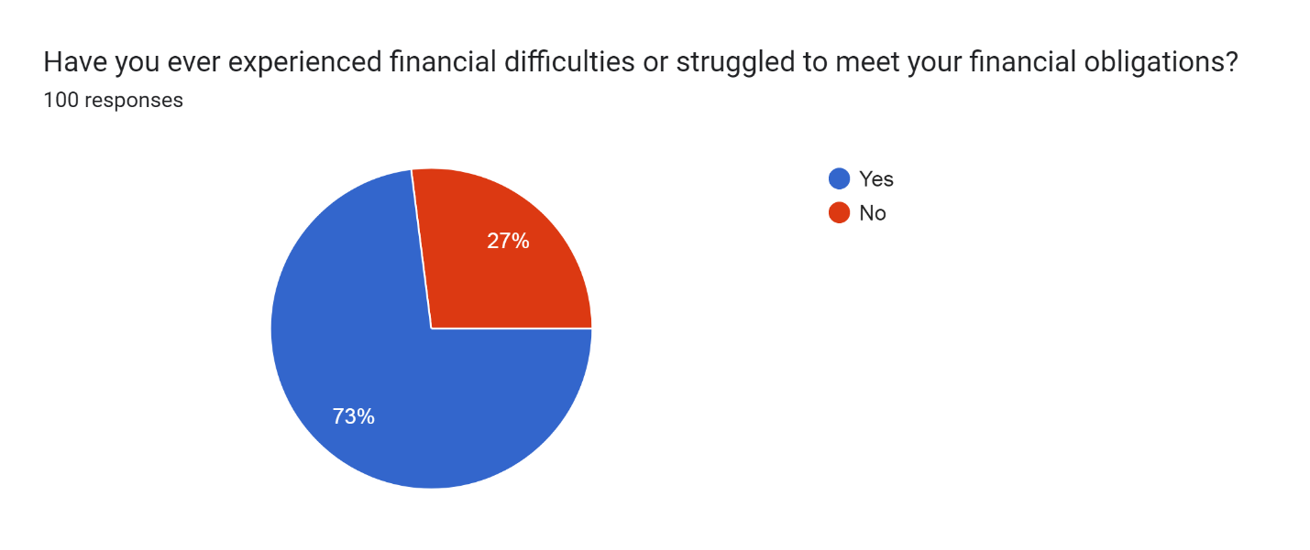The least common response is "Poor," with 13% of people rating their ability as poor. This suggests that a small percentage of people may have significant difficulty differentiating between needs and wants, and may be more likely to make impulsive or irrational purchases. Overall, the graph shows that most people have a good understanding of the difference between needs and wants, and are able to make informed purchasing decisions. However, some people may have difficulty differentiating between needs and wants, or may be more likely to make impulsive purchases.

**Figure:** Financial difficulties or struggled to meet your financial obligations

The graph shows the percentage of people who have experienced financial difficulties or struggled to meet their financial obligations. The data is based on a survey of 100 people. The majority of respondents (73%) have experienced financial difficulties or struggled to meet their financial obligations at some point in their lives. This is a significant number, and it suggests that financial difficulties are a common experience for many people. The graph also shows that some people are more likely to experience financial difficulties than others. For example, people who are unemployed or underemployed are more likely to experience financial difficulties. People who have low incomes or who are living in poverty are also more likely to experience financial difficulties.

**5. Conclusion**

This research paper has examined the economic decision-making of university students, with a focus on financial literacy and spending behavior. The results of the study showed that financial literacy is an important factor in the economic decision-making of university students. Students who are more financially literate are better able to make sound financial decisions. This can lead to a number of positive outcomes, such as lower debt levels, higher savings rates, and better credit scores.

The study also has a number of implications for policymakers and educators. Policymakers should consider developing programs to help university students improve their financial literacy. Educators should also incorporate financial literacy education into the curriculum.

**6. Recommendations**

Based on the findings of this study, the following recommendations are made:

* Policymakers should develop programs to help university students improve their financial literacy. These programs could be offered through universities, community colleges, or other organizations.
* Educators should incorporate financial literacy education into the curriculum. This could be done by offering standalone courses on financial literacy or by integrating financial literacy concepts into other courses, such as economics or mathematics.
* Universities and colleges should provide resources to help students manage their finances. These resources could include financial counseling services, budgeting workshops, and debt management programs.

**7. Limitations and Future Research**

This study has a few limitations. First, the sample size was relatively small. Second, data were collected from a small number of universities. Therefore, the results of the study may not be generalizable to all university students. Future research should include larger samples and students from a variety of universities. Additionally, examining the impact of financial education interventions on students' financial decision-making could provide valuable insights for improving financial literacy programs on campuses.

**8. References:**

Lusardi, A., & Mitchell, O. S. (2011). Financial literacy and planning: Implications for retirement wellbeing. NBER Working Paper No. 17078.

Hastings, J. S., Madrian, B. C., & Skimmyhorn, W. L. (2013). Financial literacy, financial education, and economic outcomes. Annual Review of Economics, 5(1), 347-373.

Lusardi, A., & Tufano, P. (2015). Debt literacy, financial experiences, and overindebtedness. Journal of Pension Economics & Finance, 14(4), 332-368.

Norvilitis, J. M., Merwin, M. M., Osberg, T. M., Roehling, P. V., Young, P., & Kamas, M. M. (2003). Personality factors, money attitudes, financial knowledge, and credit-card debt in college students. Journal of Applied Social Psychology, 33(5), 935-947.